Feasibility study and project selection

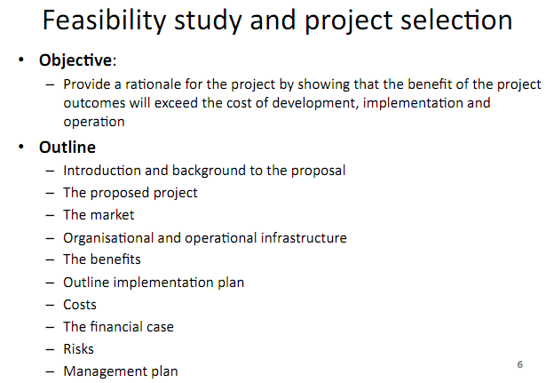

Introduction and background to the proposal

TODO

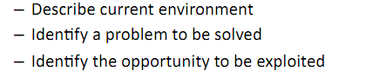

The targeted company is Harley-Davidson, Inc., a 6,300 people employing manufacturer focusing on construction and selling of heavyweight motorcycles as well as [accessories](http://www.dict.cc/englisch-deutsch/accessories.html). While the headquarters is located in Milwaukee, Wisconsin, more factories exist in North America and Europe. 83 percentages of independent dealer sales took place in U.S. and European regions generating total net revenue of US$ 4.86 billion in 2010. Further sale markets are Canada, Australia, Japan and Brazil[1].

Among Harley-Davidson’s biggest competitors are Honda, Yamaha, Suzuki, and Kawasaki. Their target field of operation is constantly growing by 13.8 percentages each year[2] [by 1994] / rapidly declining [by 2010]. Even though Harley-Davidson manages to extend its market share in North America and Europe, the total number of registrations for heavyweight motorcycles is nearly halved each year starting from 2008 / showing new strength after three years of rapid decline in 2008 – 2010[3]. Harley-Davidson manages to increase their number of new registrations by 5.9 percentages in 2011, including a 10.9 percentages growth in last quarter indicating further expansions [by 2012].

The proposed project

TODO



empty

The market

***Not needed, because no “new product or service” is expected to be created.***

Organizational and operational infrastructure

TODO

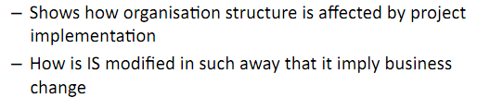

empty

The benefits

TODO

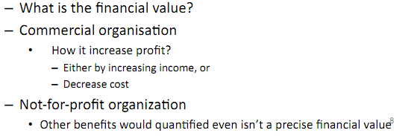

empty

Outline implementation plan

TODO

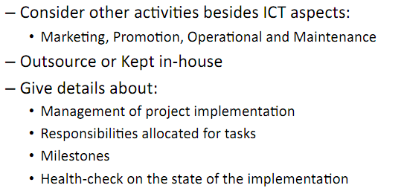

empty

Costs

TODO



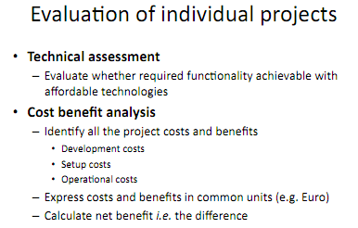

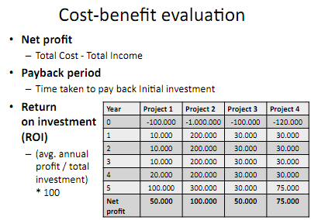

empty

The financial case

TODO

empty

Risks

TODO

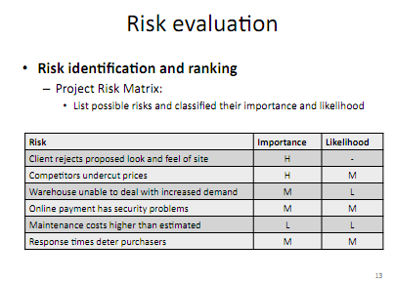

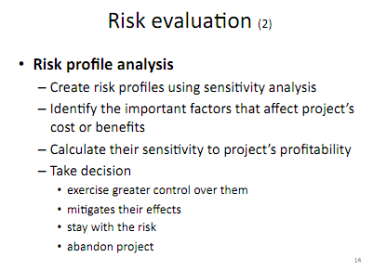

empty

Management plan

TODO

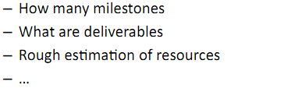

empty

Sources

Harley-Davidson announces 3rd quarter results, Unveils long-term business strategy. October 15, 2009.

<http://www.harley-davidson.com/wcm/Content/Pages/HD_News/Company/newsarticle.jsp?locale=en_US&articleLink=News/0581_press_release.hdnews&newsYear=2009&history=news>

Harley-Davidson. Annual Report 2010.

<http://www.harley-davidson.com/en_US/Media/downloads/Annual_Reports/2010/10k_2010.pdf>

Harley-Davidson Earnings, Retail Motorcycle Sales Show Continued Strength. January 24, 2012.

<http://www.harley-davidson.com/wcm/Content/Pages/HD_News/Company/newsarticle.jsp?locale=en_US&articleLink=News%2F1283_press_release.hdnews&newsYear=&history>=

1. Harley-Davidson Annual Report. 2010.
2. October/November 1998
3. Harley-Davidson Earnings, Retail Motorcycle Sales Show Continued Strength. January 24, 2012.